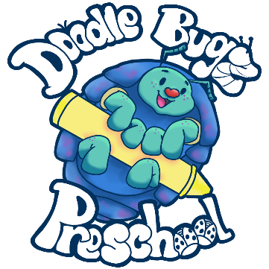

Media Release Form

Name of Child: _________________________________________

As the parent/guardian of the above child, I understand that my child may be photographed or videoed at Doodlebugz during normal preschool hours, field trips, or activities. I understand that these media may be used in promoting child care services, either in print or on the internet (e.g., Doodlebugz website, Facebook).

I have checked below the applicable option and, with my signature, grant permission regarding permissions for my child to have their images recorded for print or electronic use in promoting the Doodlebugz’s services. I understand that it is my responsibility to update this form in the event that I no longer wish to authorize the below uses. I agree that this form will remain in effect during the term of my child’s enrollment. I understand that there will be no payment for me or my child’s participation in this release.

☐ no, photos and videos for daily updates on my BrightWheel only

☐ no, photos and videos for daily updates on BrightWheel only, but okay for my child’s face to be in other children’s photos and videos

☐ yes, but no facial recognition

☐ yes, facial recognition okay

Parent/Guardian’s Name: _______________________________ Date: ___________

Parent/Guardian’s Signature: _________________________________

Relationship to Child: ______________