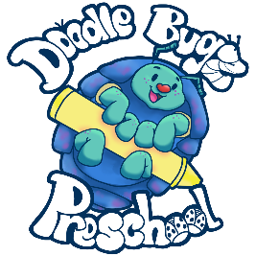

Weekly Menu

BREAKFAST (8:30-9:15am)

*Cereal, Muffins, Breads, English Muffins, Bagels, Waffles/Pancakes and a Fruit with Milk*

LUNCH (12:30-1pm)

*(Lunch can be any item under that day of the week)*

**Mexican Food Monday:**

*Rice, Beans, Tacos, Quesadillas, Nachos, Burritos, Enchiladas*

**Tuesday with Toast:**

*Lunch meat sandwiches, PB&J, Grilled Cheese, Tuna or Egg Salad sandwich*

**Pasta Wednesday:**

*Mac n Cheese, Spaghetti, Raviolis, Fettucini*

**Oven-Baked Thursday:**

*Pizza bagels, croissant dogs, English muffin toasties*

**Fun Friday:**

*Themed (lunch that matches monthly themes), Fish sticks, chicken nuggets, salmon patties, turkey burgers*

AM(10:45am-11:15am)/PM(3:30-4:15pm) SNACK

*Veggie or a Fruit & Crackers or a Protein*